Project Design Documentation Template:
Last updated: July 29th, 2026

1. Project Title & Version Control
Give your project a clear, relevant name that communicates what you are building. Include a working version so the document can be updated as the project develops.
Version Control
Version: Final_Version #1
Date: 08/13/2026
Change Log: Project Design Document Template WiP

2. Project Summary (2-3 sentences)
What is your project, why does it matter, and what value is it intended to provide? Write a brief summary that someone unfamiliar with the project can understand.
My program is business retrieval-Augmented Generation (RAG) internal AI-powered governance and security assistant that retrieves organization-specific policies, provides source backed guidance, identifies uncertainties, and routes employees to the appropriate internal resources and also the escalation pathways (if needed). The system will have access to all of the firm’s department policies, governance documentation, and employee directories and the AI will use these documents as source material to provide real-time employee guidance. The program will also act as a policy health dashboard that will show accurate comprehension gaps within the company’s guidelines. Lastly, the program will have the capability to initiate tech tickets for escalation circumstances.
3. Problem Statement / Use Case
What real-world problem or need does this project address? Who is the intended user, and when or why would they use it?
This system will address the information lapse in company policy governance by providing real time answers to employees and will provide policy owners with an active breakdown of how effective their department guidelines are.
4. Goals and Objectives
List 2-3 clear and specific project goals. Describe what the completed project must accomplish by the end of the 12-week development period.
The project must involve AI having access to a business’s internal policies/procedures, employee directories, and be able to answer employees questions while citing the exact governances that were addressed. In addition the end result should be able to provide a management level policy dashboard and the capability to create tech tickets for employees.
5. Key Features / Functions
List the main features or functions the project must include. Focus first on the essential features needed for a complete, usable minimum viable product (MVP).
- AI
- Policy Health Dashboard
- Policy feedback questionnaire
- Initiating emails to policy owners for policy review
- Initiating emails for escalation scenarios
- Creating preliminary IT tickets
6. Tech Stack and Tools
List the languages, frameworks, platforms, databases, APIs, security tools, design tools, or other technologies you expect to use. Briefly explain what each major tool will support in the project.
Technology | Purpose in the Project
Python | Primary programming language used to build the application's backend, process user questions, interact with uploaded documents, and manage business logic.
Flask (or FastAPI) | Web framework used to create the application's interface and API endpoints. Flask is beginner-friendly, while FastAPI offers more modern API features if the project grows.
HTML, CSS, JavaScript | Build the employee-facing web interface where users can ask questions, view policy answers, submit feedback, and preview emails before sending.
SQLite (development) / PostgreSQL (future) | Store user accounts, uploaded policies, employee directory information, feedback, policy owners, and system activity. SQLite is simple for development, while PostgreSQL is better for enterprise-scale deployment.
OpenAI API (or another LLM) | Interpret employee questions, summarize policy language in plain English, and generate draft emails while only using approved company documents as the knowledge source.
RAG (Retrieval-Augmented Generation) | Ensures AI answers are based on company-approved policies instead of relying solely on the model's training. This helps reduce inaccurate or "hallucinated" responses.
Vector Database (ChromaDB or FAISS) | Store searchable versions of company policy documents so the assistant can quickly retrieve the most relevant sections when employees ask questions.
PyPDF2 or PDFPlumber | Extract text from uploaded PDF policy manuals, employee handbooks, and governance documents for indexing and searching.
SMTP or Microsoft Graph API | Send employee clarification requests and policy-owner notification emails directly from the application.
Git & GitHub | Version control, collaboration, and project documentation throughout development.
Visual Studio Code | Primary development environment for writing, testing, and debugging the application.
Figma | Design wireframes and user interface mockups before building the application.
draw.io (diagrams.net) | Create system architecture diagrams, workflow diagrams, and database relationship diagrams for documentation and presentations.
JWT Authentication or Microsoft Entra ID (future enhancement) | Authenticate users and ensure employees only access information appropriate for their organization.
Logging Framework (Python Logging) | Record system activity, policy searches, errors, and feedback for auditing, troubleshooting, and security monitoring.

7. Architecture / Workflow Diagram
Create a simple diagram or flowchart showing how the project works from start to finish. Show the user or system input, the major steps or components, and the expected output. You may use AI to help draft the diagram, but review it and make sure it accurately reflects your project.
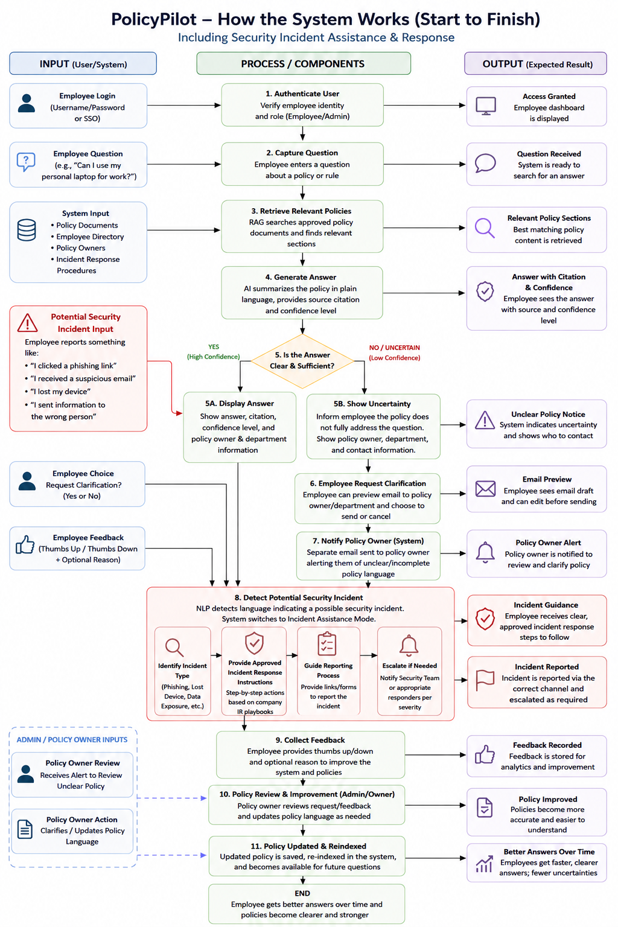
8. Timeline / Weekly Milestones
Use this section to plan how your project will move through the software development life cycle (SDLC) over 12 weeks. Adjust the specific tasks to fit your project, while keeping the overall progression from planning through release.
Week | Project Outcome | SDLC Stage and What It Means
Week 1 | Planning & Requirements Gathering: The project's purpose, intended users, stakeholders, functional needs, non-functional needs, scope, and 12-week timeline are clearly defined. | Planning & Requirements Gathering: Define the problem the policy assistant will solve, who will use it, and the overall purpose of the project before deciding what to build.
Week 2 | Research & System Design: Research RAG, AI governance, document-search methods, and policy-management systems. Complete user personas, use cases, initial system architecture, and UI wireframes in Figma. | Research & System Design: Determine how the proposed solution should work before development begins. Research appropriate technologies and translate project requirements into user workflows, interface designs, and a high-level technical architecture
Week 3 | Database & Backend Design: Complete the database structure for users, policies, departments, policy owners, employee directory information, feedback, and audit logs. Set up the development environment, GitHub repository, and Flask/FastAPI project structure. | System Design & Development Preparation: Design how project data will be organized and how the backend will support the application. Establish the technical environment and repository needed to begin building the working system.
Week 4 | Document Management Module: Develop administrator functionality for uploading company policies, extracting text from PDFs, categorizing documents, storing policy metadata, and associating policies with the appropriate department or owner. | Implementation – Document Management: Begin development of the application's core functionality by creating the process that turns company policy documents into organized, searchable information that the system can use.
Week 5 | AI Search & Policy Retrieval: Implement document indexing and Retrieval-Augmented Generation (RAG), allowing the system to locate relevant policy information and return source-backed answers with policy citations and confidence indicators. | Implementation – AI & Retrieval: Build the central intelligence of the application. Connect employee questions to approved company documents so AI responses are grounded in organizational policy rather than generated without an authoritative source.
Week 6 | Employee User Interface: Complete the employee-facing dashboard where users can enter questions, receive policy guidance, view citations and confidence information, and identify the department and policy owner responsible for the information. | Implementation – User Interface: Build the primary way employees interact with the system and connect the frontend experience to the policy-retrieval functionality developed in previous weeks.
Week 7 | Feedback & Email Workflow: Implement thumbs-up/thumbs-down feedback, employee clarification requests with email preview, and a separate policy-owner notification when unclear or incomplete policy language is identified. | Implementation – Feedback & Escalation: Build the communication loop between employees, the assistant, and policy owners. The system should not only identify uncertainty but provide a structured way to request clarification and alert policy owners to potential documentation gaps.
Week 8 | Administrator Dashboard: Complete an administrator portal for managing uploaded policies, departments, employee directory information, policy owners, feedback reports, and unresolved clarification requests. | Implementation – Administration: Provide authorized administrators with the tools necessary to maintain the information that powers the system and review feedback or policy issues identified through employee use.
Week 9 | Security & User Authentication: Implement secure login, role-based access control (RBAC), password protection, input validation, audit logging, and restrictions separating employee and administrative permissions. | Security Implementation: Apply security controls to protect company information and restrict system functionality based on user roles. Incorporate principles such as authentication, authorization, least privilege, secure input handling, and accountability.
Week 10 | Testing & Quality Assurance: Conduct unit, integration, usability, and user acceptance testing. Test policy retrieval accuracy, feedback functions, email workflows, permissions, and system performance while documenting and correcting defects. | Testing & Quality Assurance: Evaluate whether individual components and the complete application work as intended. Verify that the system meets established requirements, identify bugs or security issues, and correct problems before release.
Week 11 | Deployment Preparation: Finalize technical documentation and user guides, create installation instructions, optimize the database and interface, resolve remaining issues, and prepare the application for deployment. | Deployment Preparation: Move the tested application toward release by completing documentation, finalizing the user experience, optimizing the system, and confirming that the MVP is stable enough to deploy.
Week 12 | Deployment & Final Presentation: Deploy the completed MVP, conduct the final demonstration, present the system architecture and major features, discuss future enhancements, collect feedback, and document lessons learned. | Release & Deployment: Release the working MVP and demonstrate that it meets the project's original objectives. Evaluate the completed product, document lessons learned, gather stakeholder feedback, and identify opportunities for future development.

9. Risks and Risk Mitigation
Identify risks that could affect successful completion of the project and explain how you will reduce or respond to each risk. Consider scope, time, technical difficulty, missing requirements, data, security, access to tools, and dependencies.

Risk | How It Could Affect the Project | How I Will Reduce/Respond to the Risk
Scope becomes too large | Planning & Requirements Gathering: The project's purpose, intended users, stakeholders, functional needs, non-functional needs, scope, and 12-week timeline are clearly defined. | Planning & Requirements Gathering: Define the problem the policy assistant will solve, who will use it, and the overall purpose of the project before deciding what to build.
Limited development time | Research & System Design: Research RAG, AI governance, document-search methods, and policy-management systems. Complete user personas, use cases, initial system architecture, and UI wireframes in Figma. | Research & System Design: Determine how the proposed solution should work before development begins. Research appropriate technologies and translate project requirements into user workflows, interface designs, and a high-level technical architecture
Scope becomes too large | The full vision includes AI/RaG, policy uploads, employee and admin interfaces, feedback, email workflows, security, analytics, and more. Trying to build every possible feature could prevent completion within 12 weeks. | Follow the established MVP and 12-week roadmap. Prioritize core functionality first and move nonessential features such as Teams/Slack integration, browser extensions, and advanced analytics to future enhancements.
Limited development time | A delay during one development phase could affect later weeks and leave insufficient time for testing and deployment. | With weekly deliverables set based on the roadmap, track incomplete tasks, and prioritize features that are required for the MVP. Allow less-critical functionality to be simplified or postponed rather than delaying the entire project.
Technical difficulty of AI/RAG integration | RAG, vector search, document processing, and AI APIs may be more technically challenging than expected and could require additional troubleshooting or learning. | Research and test the AI/RAG process early. Build a small proof of concept before connecting it to the full application. Develop individual components separately so that problems can be isolated and corrected.
AI produces inaccurate or unsupported answers | The assistant could misinterpret a policy or generate information that is not actually supported by company documentation, creating a major reliability and security concern. | Require responses to be grounded in uploaded approved documents, provide policy citations, establish confidence/uncertainty handling, and instruct the system not to provide a definitive answer when sufficient policy information cannot be found.
Policies contain missing or unclear information | A user's question may not have a definitive answer because the organization's policy itself is incomplete, vague, contradictory, or outdated. | The system will identify uncertainty instead of inventing an answer, display the responsible department and policy owner, allow the employee to request clarification, and separately notify the policy owner that the documentation may require review.
Insufficient or unrealistic test data | We will not have access to an actual company's confidential policy library, employee directory, or internal governance information during development. | Create fictional/sample company policies and employee-directory data specifically for testing. Avoid using confidential or personally identifiable information in the project demonstration.
Security and privacy vulnerabilities | The system could eventually contain internal policies, employee information, questions, and potentially sensitive business information. Unauthorized access could expose organizational data. | Incorporate authentication, RBAC, least privilege, input validation, secure credential/API-key storage, and audit logging. Use test data during development and avoid storing unnecessary sensitive information.
Unauthorized access to administrative functions | Employees could potentially access policy-upload tools, feedback analytics, directory management, or other administrator features they should not control. | Separate employee and administrator roles using role-based access control (RBAC) and test authorization to ensure restricted functions cannot be accessed simply by navigating directly to an administrative page or endpoint.
API or external service limitations | AI or email APIs may have usage limits, costs, authentication requirements, outages, or configuration issues that interfere with development. | Select accessible tools early, monitor API usage, protect API credentials, and design components so that an external service can be replaced or temporarily simulated during development and demonstrations if necessary.
Email workflow errors | Clarification requests could be routed to the wrong person, generated incorrectly, or confused with the separate policy-owner notification workflow. | Maintain the two workflows as separate processes. Display the department and policy-owner/contact information before an employee sends an inquiry, require employee review/approval of their generated email, and test routing using controlled test email accounts.
Incorrect policy ownership or directory information | If a policy is connected to the wrong department or an outdated employee contact, the system could direct users to the wrong resource. | Store policy ownership separately from policy content, validate department/owner information during policy upload, and allow authorized administrators to update directory and policy-owner records without changing the policy itself.
Changing or missing requirements | New ideas may continue to emerge during development, causing requirements to change after development has already started. | Document requirements and success criteria during the early SDLC stages. Evaluate new ideas against the MVP before adding them. Record valuable ideas that are not essential as future enhancements instead of automatically expanding the current build.
Integration discrepancies | Individual components may work separately but fail when connected—for example, AI retrieval may work but fail to correctly identify the policy owner needed by the email workflow. | Develop modular components, define consistent data structures, and perform integration testing as features are connected. Week 10 will include dedicated end-to-end testing of complete employee and administrator workflows.
Loss of code or unstable changes | A coding error or unsuccessful update could damage previously working functionality and delay the project. | Use Git and GitHub version control, make regular commits after working milestones, use descriptive commit messages, and test new functionality before merging major changes into the stable version.
Testing time becomes compressed | If development runs late, testing may be rushed even though this application depends heavily on accuracy and security. | Test individual features throughout development instead of waiting until Week 10. Week 10 remains the dedicated QA phase for integration, security, usability, and user acceptance testing.
Deployment or environment differences | An application that works locally in VS Code may encounter dependency, configuration, database, or API issues when deployed. | Document dependencies and environment variables throughout development, maintain installation instructions, and conduct deployment testing before the final Week 12 release.

10. Evaluation Criteria
How will you know the project is complete and working well? List at least 3 measurable success criteria, including whether the required features work, the project meets the intended user need, and the final product can be demonstrated or published.
- AI and RAG components are efficient and functional when attending to an employee’s request
- Policy Health Dashboard captures the feedback analytical data in an aesthetic and easy-to-comprehend layout for policy owners
- Both employee and admin interfaces are functional and can run simultaneously without interruptions
- Employee policy feedback and questionnaire flow correctly to the admin dashboard
- Initiating emails to policy owners for policy review
- Initiating emails for employee escalation scenarios
- Creating preliminary IT tickets requests
11. Future Considerations
What improvements, additional features, maintenance, or next steps would you pursue after this version is complete? Separate future ideas from the work required for the current 12-week project.

Future Improvement | What It Would Be the Project Impact
Microsoft Teams / Slack Integration | Allow employees to ask policy questions directly through communication platforms they already use instead of opening the standalone application.
Browser Extension | Give employees quick access to the assistant while working in other browser-based company systems.
Microsoft Entra ID / Single Sign-On (SSO) | Allow employees to authenticate using existing company credentials and provide stronger enterprise identity and access management.
Advanced Policy Analytics Dashboard | Show trends such as frequently questioned policies, clarification requests, negative feedback, commonly misunderstood topics, and policies that may require review.
Policy Health Scoring | Develop a scoring system that uses employee feedback, unanswered questions, policy age, and clarification frequency to identify policies that may need attention.
Policy Version Control & History | Track when policies are changed, who approved the changes, previous versions, effective dates, and which version was used to answer an employee's question.
Policy Review & Approval Workflow | Allow policy owners to draft revisions and route them through the appropriate approval process before updated language becomes an official source for the assistant.
Automated Policy Review Reminders | Notify policy owners when documents reach scheduled review dates or may be outdated.
Improved Policy-Gap Detection | Analyze repeated unanswered or low-confidence questions to identify areas where company guidance may be missing entirely—not just unclear.
Employee Follow-Up Tracking | Allow employees who request clarification to track the status of their inquiry and receive notification when an answer is provided.
ServiceNow / Ticketing Integration | Automatically create and track support, compliance, security, or policy clarification tickets when questions require human intervention.
Context-Aware Answers | With appropriate permissions, tailor guidance based on an employee's department, location, job role, or access level when different policies apply to different groups.
Multilingual Support | Allow employees to ask questions and receive policy explanations in supported languages while maintaining the meaning of the official policy.
Accessibility Improvements | Expand keyboard navigation, screen-reader support, contrast options, text sizing, and other accessibility features.
Mobile Optimization / Application | Provide a more complete mobile experience for employees who need policy guidance away from their computers.
Security Incident Assistance | Recognize statements such as “I clicked a phishing link” and transition from ordinary policy lookup to approved incident-reporting instructions and escalation procedures.
Employee Training Recommendations | Recommend relevant security-awareness or compliance training when patterns indicate that employees repeatedly misunderstand a particular policy area.
Additional Enterprise Integrations | Connect with company intranets, HR systems, document-management platforms, identity systems, or other approved internal knowledge sources.
Advanced Reporting & Governance Metrics | Generate reports for Security, Compliance, HR, Legal, or leadership showing policy effectiveness, recurring knowledge gaps, and improvement trends.

